26.60: a) Using the currents as defined on the circuit diagram below we obtain three equations to solve for the currents:
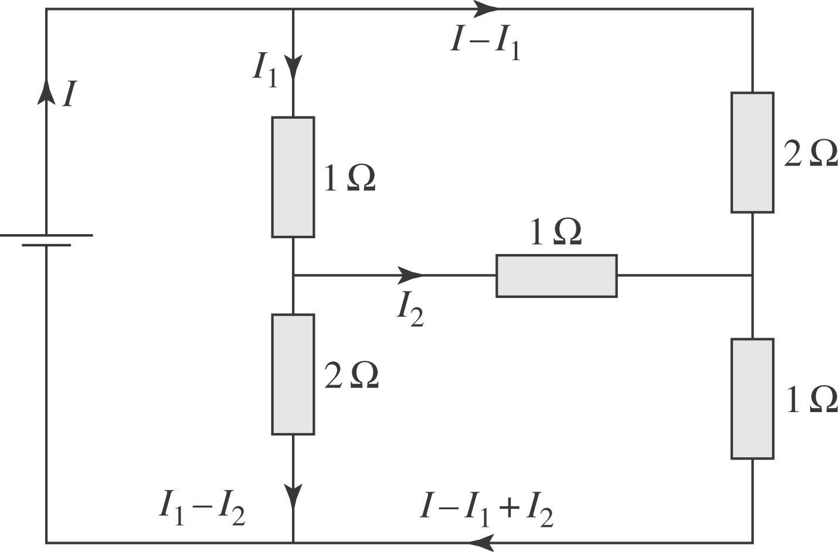
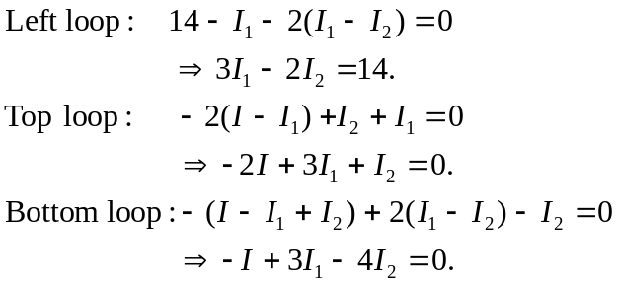
Solving these equations for the currents we find:
So the other currents are:
